Homefield C of E Primary School
Newsletter November 2023
Headteacher Update
Thank you to everyone that came to our Parents Evening, we really appreciate your support and it was great to get your feedback via our parent’s questionnaire.
The children have been busy enjoying the changes we have made to our lunchtime play zones. I hope you have liked seeing the children’s playground art on the path outside our Year 6 classroom!
We have lots of Christmas events planned for December 23, we are really pleased to be joining together with Rev Steve Deall and the church community to bring some new Christmas events this year. Please have a look a have at the diary dates on the last page

Please note that tickets for the Christmas performance will be limited to 2 per child, you will be able to book your tickets via our google form. The link for the google form will be sent out on Monday on 27th December via email so please look out for it. Tickets will be printed and sent home with the children.

Thank you for your continued support
Miss Read
Anti-Bullying
Here are some of the messages we are sharing as part of our Anti-bullying focus
What is Bullying?
“The repetitive, intentional hurting of one person or group by another person or group, where the relationship involves an imbalance of power. Bullying can be physical, verbal or psychological.
It can happen face to face or online”
What is Banter?
“The playful and friendly exchange of teasing remarks.”
It’s not banter if…
You would be upset if someone said it to you
It's hurtful
You're not friends
Someone's asked you to stop
The target isn't laughing
It focuses on someone's insecurities
Please help us by reinforcing and talking about this messages at home
Online Safety
Our new Online Safety Policy is available on the school website, please click the link below to access it.
https://www.homefield.norfolk.sch.uk/page/?title=Online+Safety&pid=92

Here are some short video clips to watch with your children to help them keep themselves safe online. We hope you enjoy watching them together and please speak to a member of staff if you have any questions

Our three-episode animation for 8-10 year olds helps them to learn how to spot pressuring and manipulative behaviour online and to stay safe from other risks they might encounter online
https://www.thinkuknow.co.uk/parents/jessie-and-friends/

This series of three animations aims to give 4-7 year olds knowledge, skills and confidence to help them respond safely to risks they may encounter online.
https://www.thinkuknow.co.uk/parents/playlikeshare/

Music
We are excited to have secured whole class musical instrument tuition, arranged via Norfolk Music Hub. We have been busy developing our music curriculum and we are very passionate about all children having the opportunity to learn how to play musical instruments, engaging in the joy of music!
Mr Ward from Norfolk Music Hub will be coming into school weekly to provide teaching for Year 5 and 6 initially. We then plan to deliver the music teaching as a part of a rolling programme ensuring that as many children as possible have access to this provision during their time at Homefield.

Norfolk Music Hub will be running an after school club in January for KS2 pupils. Due to budget restrictions this will be chargeable and paid in advance, per half term block, further details and booking details will follow in a separate letter.
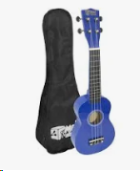
Attendance
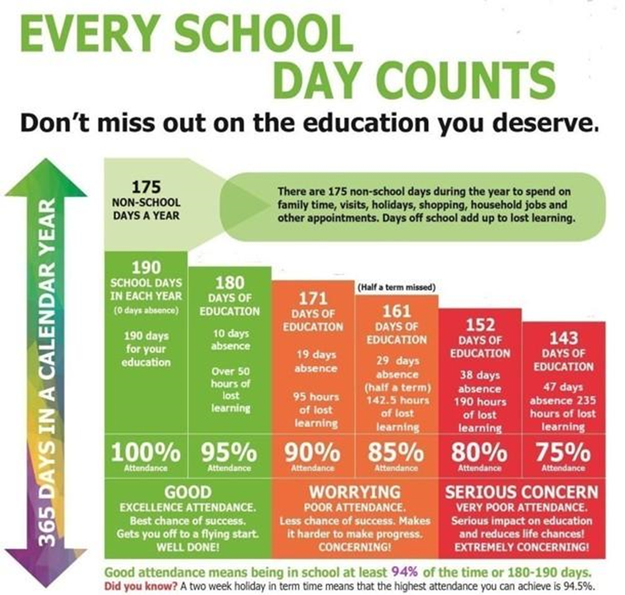
Our attendance target | 96%
Our attendance for Autumn 1 | 95%
Number of unauthorised days absence this term | 111

Class attendance results for November

- Year 1 - 93.8%
- Year 2 - 92.0%
- Year 3 - 93.8%
- Year 4 - 94.3%
- Year 5 - 94.6%
- Year 6 - 97.5%

Years 1, 2, 4, 5 and 6 have all made excellent progress around the Attendanceopoly board, with Year 1 winning 10 minutes of extra play time!
Well done to all pupils contributing to excellent class attendance every week.
#everydaycounts
Reading
A big well done to the following children who have recorded the most reads on BoomReader during November.
YR Elizabeth
Y1 Teddy
Y2 Freddie
Y3 Jace
Y4 Henry
Y5 Clementine
Y6 Harrison
Congratulations to Year 5, who collectively have logged more reads than any other class!
Year 5 - 51%
Please keep logging your children’s reads, it allows them to move around our class maps and we will soon be introducing class rewards for the class with the most reads each week.
Thrive

Consent letters were sent home via email, these are just to get your consent if your child ever needed to access a Thrive session. If your child has been identified to receive support via our Thrive sessions then you should have received a phone call from Mrs Clarke to discuss this and why we have thought it was a good idea.
Thrive sessions are to help support children in a wide range of areas but specifically with their mental health and wellbeing, this may be to support building their confidence, anxiety or it may be to help if a child struggles in class. It will give them targeted strategies and activities. These are normally in a small group of three to four children who will come out for about thirty minutes once or twice a week. It is done in a fun way with also some reflection time to help understand our feelings and behaviour.

We have 2 Thrive trained members of staff at Homefield C of E Primary
Miss Everett and Mrs Clarke
If you would like to talk to us about supporting your child through Thrive please do not hesitate to pop in or email the office.

Forest Schools
Forest School sessions will take place every Thursday, for 6 week blocks. The children will have their 1hr Forest Schools session as a class group with their class teacher, teaching assistant and Claire Day (Forest School Leader)
Further details about Forest School will be included in a separate letter, please look out for it in your inbox.
 | Nursery | Reception | Year 1 | Year 2 | Year 3 | Year4 | Year 5 | Year 6
Autumn 2 |  |  |  |  |  | Forest school | Forest School | Forest School
Spring 1 |  |  | Forest school | Forest school | Forest school
Spring 2 | Forest school | Forest school
Summer 1 | * | * |  |  |  | Forest school | Forest school | Forest school
Summer 2 |  |  | Forest school | Forest school | Forest school

*Please note that Nursery and Reception will be having an additional Forest School block in the Summer Term, further details to follow.

Extra Curricular clubs Autumn 2
Monday | Netball | Y3-6 | ENSFC
Tuesday | Boys’ Football | Y5-6 | Premier Sport
Wednesday | Musical Theatre | Y3-6 | Premier Sport
 | Choir | Y2-6 | Miss Everett
Thursday | Tennis | Y5-6 | Mike Reynolds
 | Multi Skills | Y1-3 | Premier Sport
Friday | Girls’ Football | Y3-6 | ENSFC

We also have our usual Breakfast and After School Club.
Learning Round Up
Please use our facebook page to keep up to date with our weekly learning round up for all classes
Facebook page: Homefield VC Primary
Meet our Governor
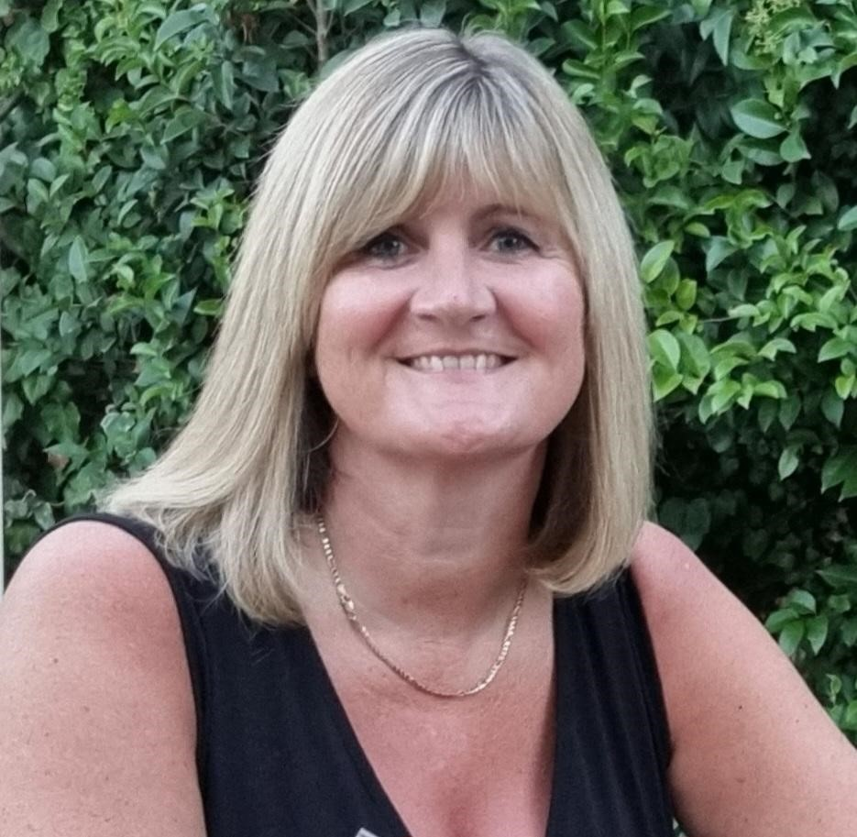
Mrs Jo Viner – Local Authority Governor
I have served in schools in Suffolk for over twenty years as a teacher, governor and headteacher. I am passionate about ensuring children have equitable access to high quality educational opportunities at the heart of their communities. I am excited to serve Homefield C of E Primary School which is very close to where I grew up in Gorleston. I have two grown up children and a dog called Reggie. In my spare time, I enjoy taking trips in our caravan as well as travelling abroad.

Christmas Diary Dates

Date | Event | Year Group
5th December  9.45 - 10.45 - Reception  10.45 - 11.30 - Nursery | Early Years Christmas family cafe | Nursery & Reception
6th December  9-9:40am &  2:30 – 3:10pm | Christmas Nativity Concert | Year 1, 2 &3
7th December  9-9:40am &  5:30-6:15pm | Christmas Carol Concert | Year 4, 5 & 6
^{Saturday 9th December}  Bookings for 3 sessions: 10-11:30, 11:30-1:00, 1:00-2:30 | Snack with Santa: PTA event  More information and booking details to follow | All year groups  Nursery – Year 6
^{11th December}  ^{9am} | Christmas Service at St Nicholas Church | Yr 2- Yr 6
14th December | Christmas Jumper/Christmas dress up  Christmas Dinner | Nursery – Yr 6
^{14th December}  ^{6pm} | Christmas Family service at St Nicholas Church, Bradwell  All Homefield families welcome, the PTA will be selling refreshments | Nursery – Year 6
^{18th December}  ^{1:30pm – 2:30pm} | Robin Hood Pantomime on line with Chanranga Music Service | Nursery – Year 6

