Birth To Five Matters ‘ranges’ that are applicable to Physical Development in the Early Years Foundation Stage (EYFS)
https://birthto5matters.org.uk/learning-development/ranges/
Children join our Nursery, aged 3 years (36 months). Range 5 (36-48 months) is therefore appropriate in Nursery. Range 6 is for Reception (48-71 months).
At the end of Reception, children are assessed against the Early Learning Goals. Physical Development covers 2 areas: fine motor skills and gross motor skills.
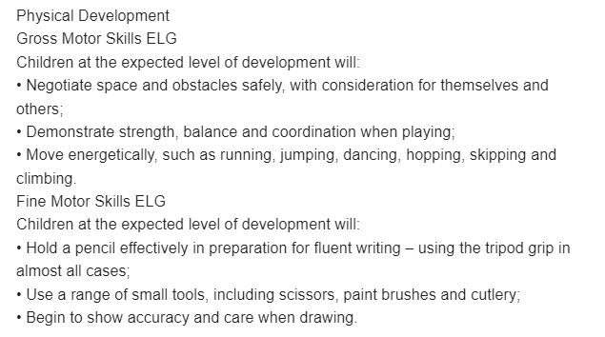

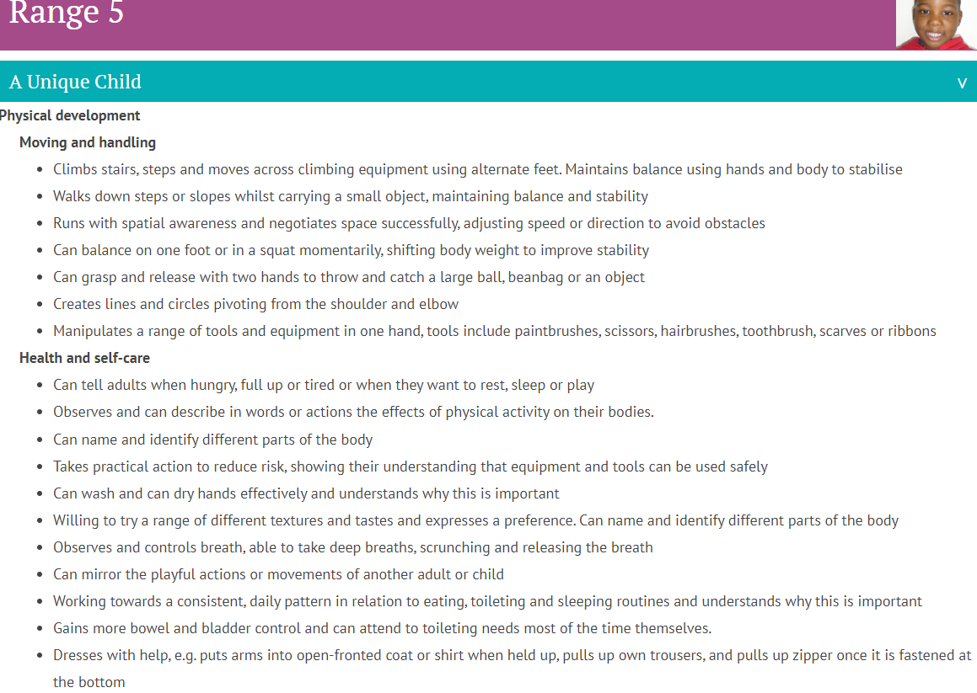
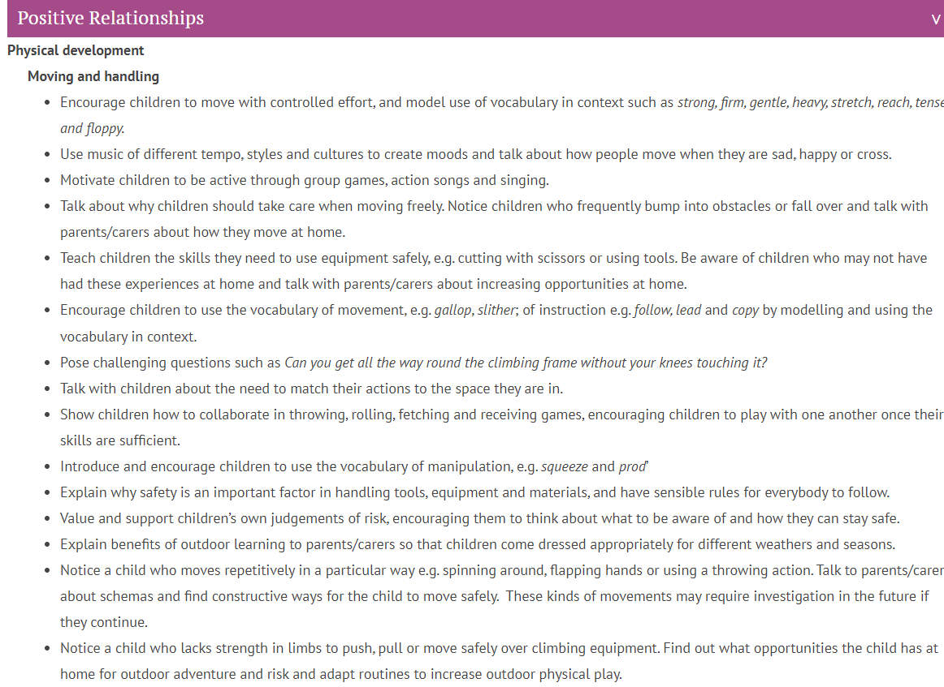
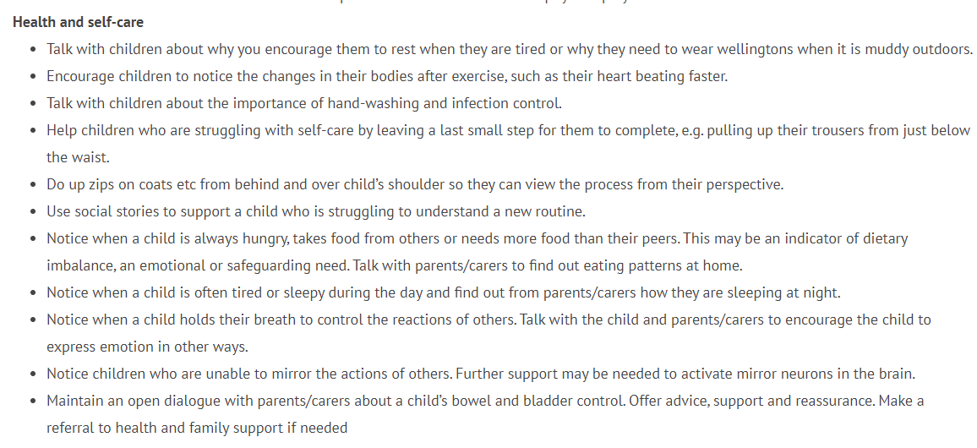

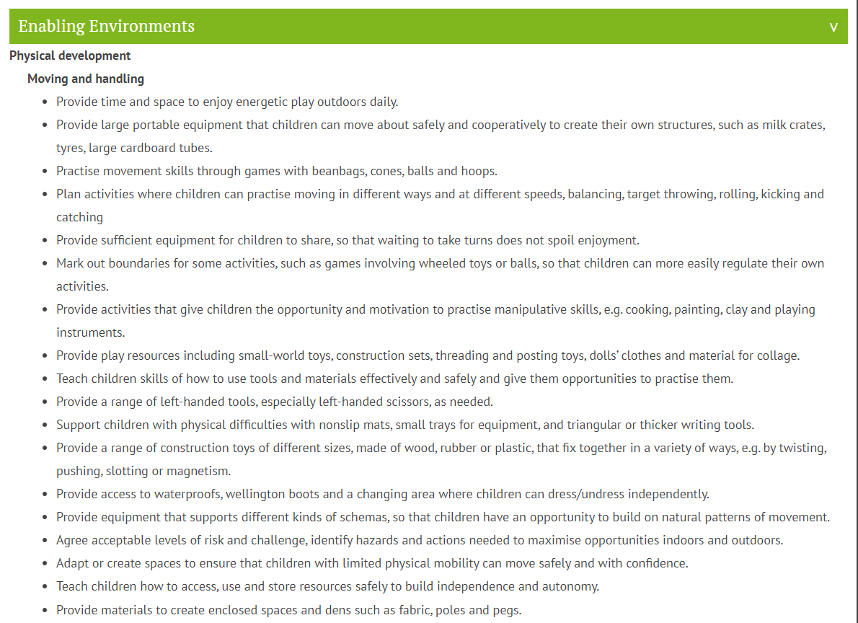
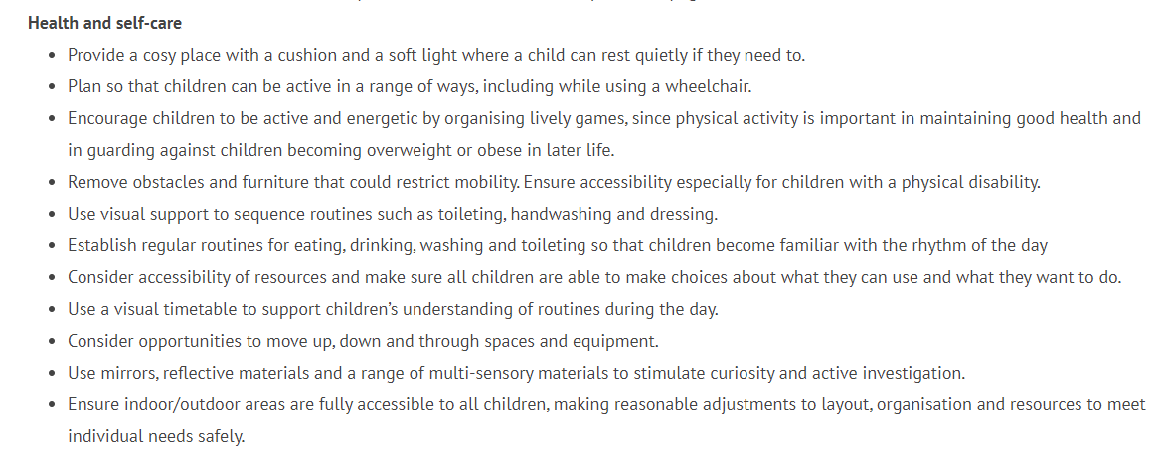
Range 6

